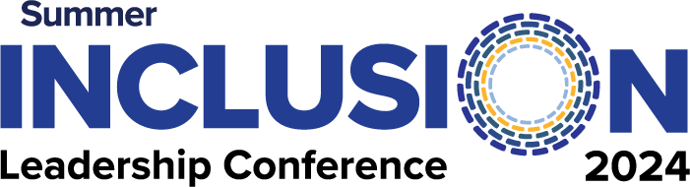
Advertising Application
June 7, 2024 | 8:00am-3:30pm
Kean University | Union, New Jersey

www.njcie.org/exhibiting-and-advertising

Send application to: samantha@njcie.org
Deadline: May 1, 2024 is the last day to purchase or submit ads

Advertisements are placed in our conference program booklet, which is distributed to all attendees.

Company Name
Contact First and Last Name
Address
City/State/Zip
Phone |  | Email
Website

FEES: (Select advertisement size below)
 | Quarter-Page Ad | $300 |  | Half-Page Ad | $500 |  | Full-Page Ad | $1,000

PAYMENT: (Please indicate your payment method)
 | CREDIT CARD # |  |  |  |  | AMOUNT |  |  |  | MASTERCARD |  |  |  | VISA
 | NAME |  |  |  | EXP. DATE |  |  |  |  |  | CVV #
 | BILLING ADDRESS
 | CHECK # |  | AMOUNT

Returning the completed application:
- EMAIL the form to: Samantha@njcie.org
- MAIL and address any checks to:
NJCIE
229 Main Street #1340
Little Falls, NJ 07424
- Once application is completed, you will be emailed instructions on how to submit your ad.

